第二章 多元正太分布及参数的估计

2.2 多远正太分布的定义及基本性质

绘制二元正太密度函数的图形及相应的等高线图形

1. r=0

sas程序

data chapter1;

r=0;

det=1\*(1-r\*r);

do x =-3 to 3 by 0.0001;

do y =-3 to 3 by 0.0001;

z=1/(2\*3.141592657\*det)\*exp(-0.5/det\*(x\*x+y\*y-2\*r\*x\*y));

output;

end;

keep x y z;

run;

proc g3d;

plot x\*y=z;

run;

proc gcontour;

plot x\*y=z;

run;

sas输出结果

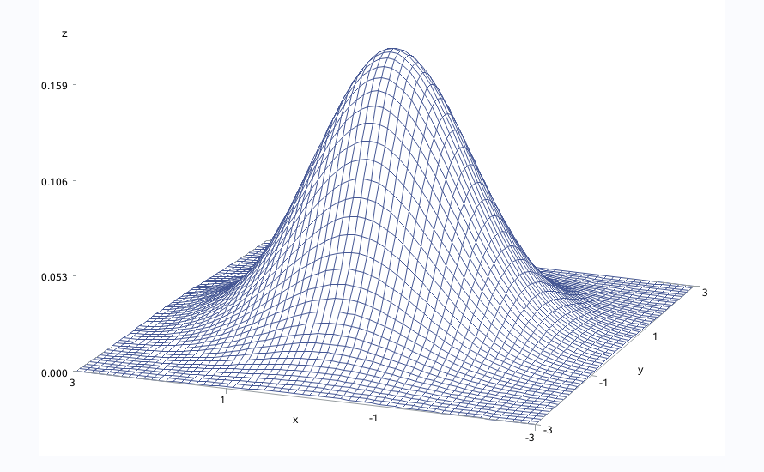 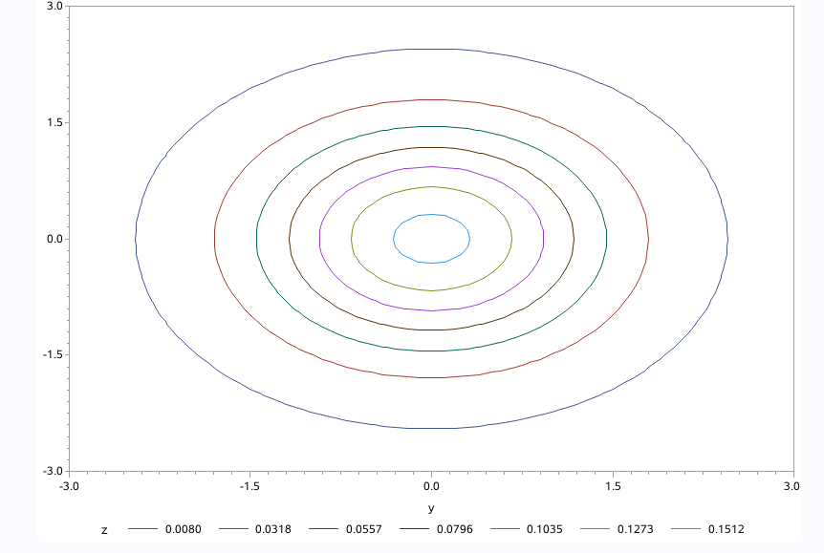

1. r=0.5时

sas程序

data chapter1;

r=0.5;

det=1\*(1-r\*r);

do x =-3 to 3 by 0.0001;

do y =-3 to 3 by 0.0001;

z=1/(2\*3.141592657\*det)\*exp(-0.5/det\*(x\*x+y\*y-2\*r\*x\*y));

output;

end;

keep x y z;

run;

proc g3d;

plot x\*y=z;

run;

proc gcontour;

plot x\*y=z;

run;

sas输出结果

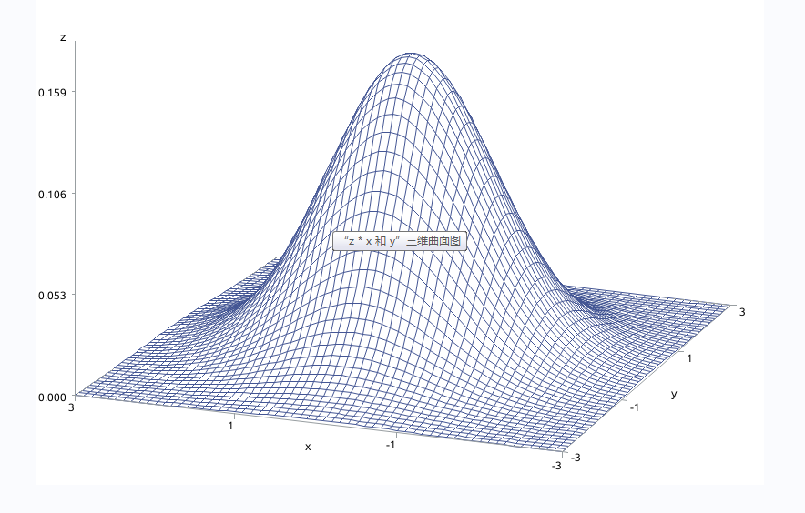

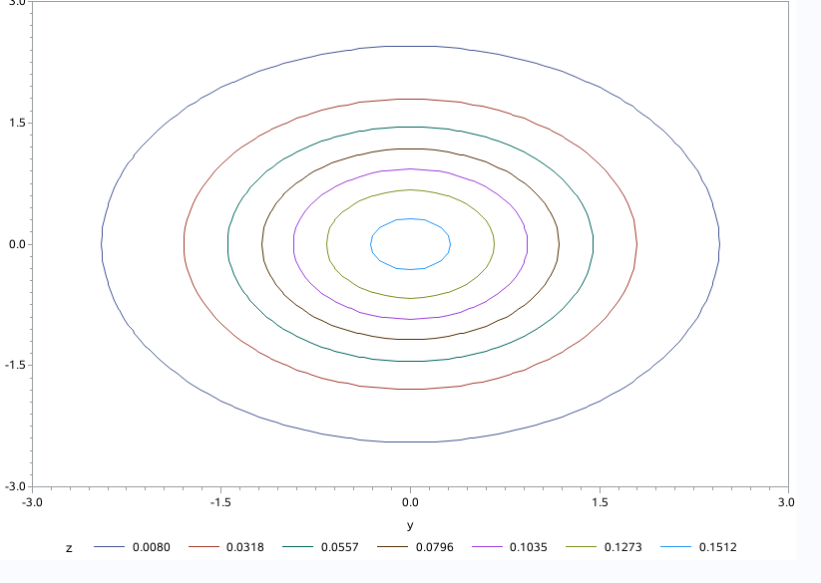

1. r=-0.5时

sas程序

data chapter1;

r=-0.5;

det=1\*(1-r\*r);

do x =-3 to 3 by 0.0001;

do y =-3 to 3 by 0.0001;

z=1/(2\*3.141592657\*det)\*exp(-0.5/det\*(x\*x+y\*y-2\*r\*x\*y));

output;

end;

keep x y z;

run;

proc g3d;

plot x\*y=z;

run;

proc gcontour;

plot x\*y=z;

run;

